Hansard, Allan (from Linked In)
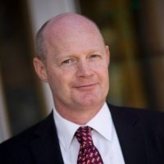

Bachelor of Science (Forestry) Australian National University 1983, B/Ec-BSc Grad Dip Res Econ, Economics - Resource Economics – Forestry 1980 – 1992.

Research Development Manager Australian Bureau of Agriculture and Resource Economics 2003 –2005. Manager - Treasury DAFF Taxation Review into Plantation Taxation Department of Agriculture Fisheries and Forestry Australia 2005 –2006. Chief Executive Officer Tree Plantations Australia 2006 –2008. Chief Executive Officer NAFI 2008 –2011. CEO of the National Association of Forest Industries, the peak body representing Australia's forest industries. Prior to his appointment as CEO of NAFI, he spent two years as Deputy CEO of the Association as well as CEO of Tree Plantations Australia. Chief Executive Officer (Transitional) Australian Forest Products Association 2011. Chief Executive Australian Fishing Trade Association (AFTA) 2012 – , Canberra. Member of Australian Forest Growers (AFG) (current Nthn NSW branch president), Institute of Foresters of Australia (IFA). Activities and Societies: Bruce Hall, Forestry Students Society President.

